**Source Control Systems**

**Source Control Repositories for Team Collaboration: SVN, TFS, Git**

Table of Contents

1. Software Configuration Management (SCM)
2. Version Control Systems: Philosophy
3. Versioning Models

Lock-Modify-Unlock

Copy-Modify-Merge

Distributed Version Control

1. Tags and Branching
2. Subversion, Git, TFS – Demo
3. Project Hosting Sites

**Software Configuration Management (SCM)**

Version Control ≈ Software Configuration Management (SCM)

* A software engineering discipline
* Consists of techniques, practices and tools for working on shared source code and files
* Mechanisms for management, control and tracking the changes
* Defines the process of change management
* Keeps track of what is happening in the project
* Solves conflicts in the changes

SCM and the Software Development Lifecycle

Version Control

* Managing Different Version of the Same File / Document

Version Control Systems (VCS)

* Functionality
* File versions control
* Merge and differences search
* Branching
* File locking
* Console and GUI clients
* Well known products
* CVS, Subversion (SVN) – free, open source
* Git, Mercurial – distributed, free, open source
* Perforce, Microsoft TFS – free

Version Control

* Constantly used in software engineering
  + During the software development
  + While working with documents
* Changes are identified with an increment of the version number
  + for example 1.0, 2.0, 2.17
* Version numbers are historically linked with the person who created them
  + Full change logs are kept

Change Log

* Systems for version control keep a complete change log (history)
  + The date and hour of every change
  + The user who made the change
  + The files changed + old and new version
* Old versions can be retrieved, examined and compared
* It is possible to return to an old version (revert)

Vocabulary

* Repository (source control repository)
  + A server that stores the files (documents)
  + Keeps a change log
* Revision, Version
  + Individual version (state) of a document that is a result of multiple changes
* Check-Out, Clone
  + Retrieves a working copy of the files from a remote repository into a local directory
  + It is possible to lock the files
* Change
  + A modification to a local file (document) that is under version control
* Change Set, Change List
  + A set of changes to multiple files that are going to be committed at the same time
* Commit, Check-In
  + Submits the changes made from the local working copy to the repository
  + Automatically creates a new version
  + Conflicts may occur!
* Conflict
  + The simultaneous change to a certain file by multiple users
  + Can be solved automatically and manually
* Update, Get Latest Version, Fetch / Pull
  + Download the latest version of the files from the repository to a local working directory
* Undo Check-Out, Revert / Undo Changes
  + Cancels the local changes
  + Restores their state from the repository
* Merge
  + Combines the changes to a file changed locally and simultaneously in the repository
  + Can be automated in most cases
* Label, Tag
  + Labels mark with a name a group of files in a given version
  + For example a release
* Branching
  + Division of the repositories in a number of separate work flows

**Subversion**

Using Subversion and TortoiseSVN

* Subversion (SVN)
* Open source SCM repository
* [http://subversion.tigris.org](http://subversion.tigris.org/)
* Runs on UNIX, Linux, Windows
* Console client
* svn
* GUI client
* TortoiseSVN – [http://tortoisesvn.tigris.org](http://tortoisesvn.tigris.org/)
* Visual Studio / Eclipse plug-ins

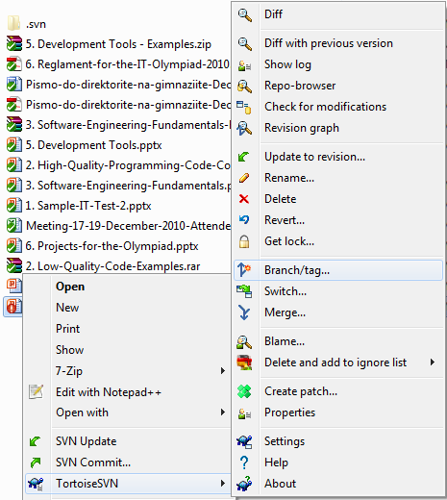Subversion – Features

* Versioning of the directory structure
* Complete change log
* Deletion of files and directories
* Renaming of files and directories
* Saving of files or directories
* Can work on it’s own or integrated with Apache as a module
* Works effectively with tags and branching

TortoiseSVN

* TortoiseSVN
* Open source GUI client for Subversion
* Integrated in Windows Explorer
* [http://tortoisesvn.tigris.org](http://tortoisesvn.tigris.org/)

Subversion & TortoiseSVN – Live Demo

**Versioning Models**

Lock-Modify-Unlock, Copy-Modify-Merge, Distributed Version Control

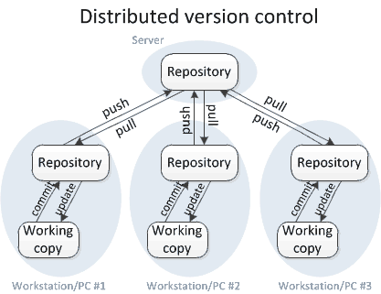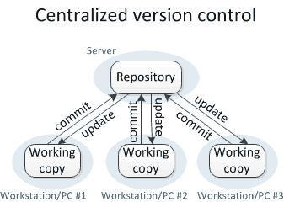

**Versioning Models**

* Lock-Modify-Unlock
  + Only one user works on a given file at a time
    - No conflicts occur
    - Users wait each other for the locked files 🡪 works for small development teams only
    - Pessimistic concurrency control
  + Examples:
    - Visual SourceSafe (old fashioned)
    - TFS, SVN, Git (with exclusive locking)
  + Lock-modify-unlock is rarely used
* Copy-Modify-Merge
* Users make parallel changes to their own working copies
* Conflicts are possible when multiple user edit the same file
* Conflicting changes are merged and the final version emerges (automatic and manual merge)
* Optimistic concurrency control
* Examples: SVN, TFS, Git
* Distributed Version Control
* Users work in their own repository
* Using the Lock-Modify-Unlock model
* Local changes are locally committed
* No concurrency, no local conflicts
* From time to time, the local repository is pushed to the central repository
* Conflicts are possible and merges often occur
* Example of distributed version control systems: Git, Mercurial

Problems with Locking

* Administrative problems:
* Someone locks a given file and forgets about it
* Time is lost while waiting for someone to release a file 🡪 works in small teams only
* Unneeded locking of the whole file
* Different changes are not necessary in conflict
* Example of non-conflicting changes:
* Andy works at the begging of the file
* Bobby works at the end of the file

Merging Problems

* If a given file is concurrently modified, it is necessary to merge the changes
* Merging is hard!
* It is not always possible to do it automatically
* Responsibility and coordination between the developers is required
* Commit changes as early as finished
* Do not commit code that does not compile or blocks the work of the others
* Leave comments at each commit

File Comparison / Merge Tools

* During manual merge use file comparison
* There are visual comparison / merge tools:
* TortoiseMerge
* WinDiff
* AraxisMerge
* WinMerge
* BeyondCompare
* CompareIt
* …

File Comparison – Example

The "Lock-Modify-Unlock" Model

The "Copy-Modify-Merge" Model 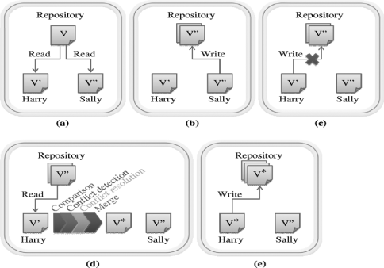

**The "Distributed Version Control" Versioning Model**



**Tags and Branches**

Tags

* Allows us to give a name to a group of files in a certain version

Branching

* Branching allows a group of changes to be separated in a development line
* Different developers work in different branches
* Branching is suitable for:
* Development of new feature or fix in a new version of the product (for example version 2.0)
* Features are invisible in the main development line until merged with it
* You can still make changes in the older version (for example version 1.0.1)

Merging Branches

* Some companies work in separate branches
* For each new feature / fix / task
* Once a feature / fix / task is completed
* It is tested locally and committed in its branch
* Finally it should be merged into the main development line
* Merging is done locally
* Conflicts are resolved locally
* If the merge is tested and works well, it is integrated back in the main development line

Branching – Example

Merging Branches – Example

Team Foundation Server (TFS)

* Team Foundation Server (TFS)
* SCM repository from Microsoft
* Integrated source control, team collaboration and project tracking system
* Deep integration with Visual Studio
* Team Explorer
* TFS client – free download from Microsoft
* Fully integrated into Visual Studio
* Part of VS 2012, additional download in VS 2010

CodePlex – Open Source Project Hosting with TFS

* CodePlex
* Community site for open source projects (mostly .NET projects)
* Operated and supported by Microsoft
* Provides free public TFS repository for open source projects
* Anyone can register as developer, join existing projects and create own projects
* Web site: [http://codeplex.com](http://codeplex.com/)

MS Team Foundation Service –TFS Hosting from Microsoft

* MS Team Foundation Service
* Private TFS server infrastructure in the cloud
* Operated and supported by Microsoft
* Free TFS repository for 5 users
  + - Paid plans for bigger projects
* Anyone can register as developer, join existing projects and create own projects
* Web site: [http://tfs.visualstudio.com](http://tfs.visualstudio.com/)
* Team Foundation Server at tfs.visualstudio.com - Live Demo

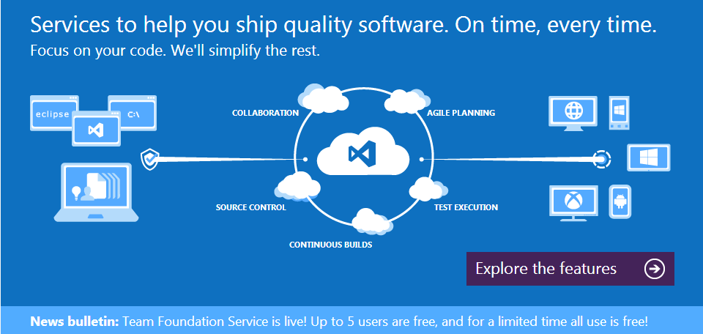

Git Crash Course

* Git
* Distributed source-control system
* Work with local and remote repositories
* Git bash – command line interface for Git
* Free, open-source
* Has Windows version (msysGit)
  + - [http://msysgit.github.com](http://msysgit.github.com/)
* msysGit Installation
* “Next, Next, Next” does the trick
* Options to select (they should be selected by default)
  + - “Use Git Bash only”
    - “Checkout Windows-style, commit Unix-style endings”
    - Note: this concerns only beginners
* Using Git Bash
* Standard command prompt with added features
* Creating a local repository
  + - git init
* Preparing (adding/choosing) files for a commit
  + - git add [filename] ("git add ." adds everything)
* Committing to a local repository
  + - git commit –m "[your message here]"
* Git “remote”– name for a repository URL
* Git “master” – the current local branch (think of it as “where you have committed”)
* Creating a remote
  + - git add remote [remote name] [remote url]
* Pushing to a remote (sending to a remote repository)
  + - git push [remote name] master
* Using Git Bash - Live Demo

Project Hosting and Team Collaboration Sites

SourceForge, Google Code, CodePlex, Project Locker

**Project Hosting Sites**

* GitHub – [https://github.com](https://github.com/)
* The #1 project hosting site in the world
* Free for open-source projects
* Has paid plans for private projects
* TourtoiseGit exists for Git source controls
* <https://code.google.com/p/tortoisegit/>
* Dramatically simplifies Git
* Perfect for beginners
* Same as the SVN version
* SourceForge – [http://www.sourceforge.net](http://www.sourceforge.net/)
* Source control (SVN, Git, …), web hosting, tracker, wiki, blog, mailing lists, file release, statistics, etc.
* Free, all projects are public and open source
* Google Code – <http://code.google.com/projecthosting/>
* Source control (SVN), file release, wiki, tracker
  + - Very simple, basic functions only, not feature-rich
* Free, all projects are public and open source
* 1-minute signup, without heavy approval process
* CodePlex – [http://www.codeplex.com](http://www.codeplex.com/)
* Microsoft's open source projects site
* Team Foundation Server (TFS) infrastructure
* Source control (TFS), issue tracker, downloads, discussions, wiki, etc.
* Free, all projects are public and open source
* Project Locker – [http://www.projectlocker.com](http://www.projectlocker.com/)
* Source control (SVN), TRAC, CI system, wiki, etc.
* Private projects (not open source)
* Free and paid editions
* Assembla – [http://www.assembla.com](http://www.assembla.com/)
* Source control (SVN, Git), issue tracker, wiki, chats, files, messages, time tracking, etc.
* Private / public projects, free and paid editions
* Bitbucket – [http://bitbucket.org](http://bitbucket.org/)
* Source control (Mercurial), issue tracker, wiki, management tools
* Private projects, free and paid editions
* Others: [Unfuddle](http://unfuddle.com/), [XP-Dev](http://www.xp-dev.com/), [Beanstalk](http://beanstalkapp.com/)
* Google Code - Live Demo
* GitHub - Live Demo

**Exercises**

1. Play with Subversion. Work in teams of 3-10 people.

* Register a SVN repository in Google Code (one per team). Add your teammates to the project.
* Upload a few of your projects (C# / HTML code / etc.).
* Each team member: change something locally. Commit your changes into the SVN repository.
* Intentionally make a conflict: each team member simultaneously edits one of the files and tries to commit. In case of conflict merge locally and commit.
* Review the Subversion history (change log).
* Revert to a previous version and commit.

1. Play with GitHub. Work in teams of 3-10 people.

* Register a Git repository in GitHub (one per team). Add your teammates to the project.
* Upload a few of your projects (C# / HTML code / etc.).
* Each team member: change something locally. Commit and push your changes into GitHub.
* Intentionally make a conflict: each team member simultaneously edits one of the files and tries to commit. In case of conflict merge locally and commit.
* Review the project history (change log) at GitHub.
* Revert to a previous version and commit.

1. Play with TFS. Work in teams of 3-10 people.

* Register a TFS account and project repository at [http://tfs.visualstudio.com](http://tfs.visualstudio.com/) (one per team).
* Upload a few of your projects (C# / HTML code / etc.).
* Each team member: change something locally. Check-in your changes into the TFS repository.
* Intentionally make a conflict: each team member simultaneously edits a file and tries to check-in. In case of conflict merge locally and check-in.
* Review the TFS history (change log) for the project.
* Revert to a previous version and check-in.

1. Create a pubic repository for your personal projects (developer profile) in GitHub or CodePlex or Google Code or somewhere else. Upload a few of your best projects in it. These project will serve as part of your CV, so select good projects only. Send as homework the link to your public repository (e.g. in a text file).